NEW JERSEY FORENSIC LEAGUE

ORIGINAL ORATORY

Code:__________ Name:________________________________

Topic:_________________________________________________

Round Number: _____ (1,2,3,SF,F) Room Number:___________

Judge Name:____________________ Affiliation:_______________
Please Print Name and Affiliation
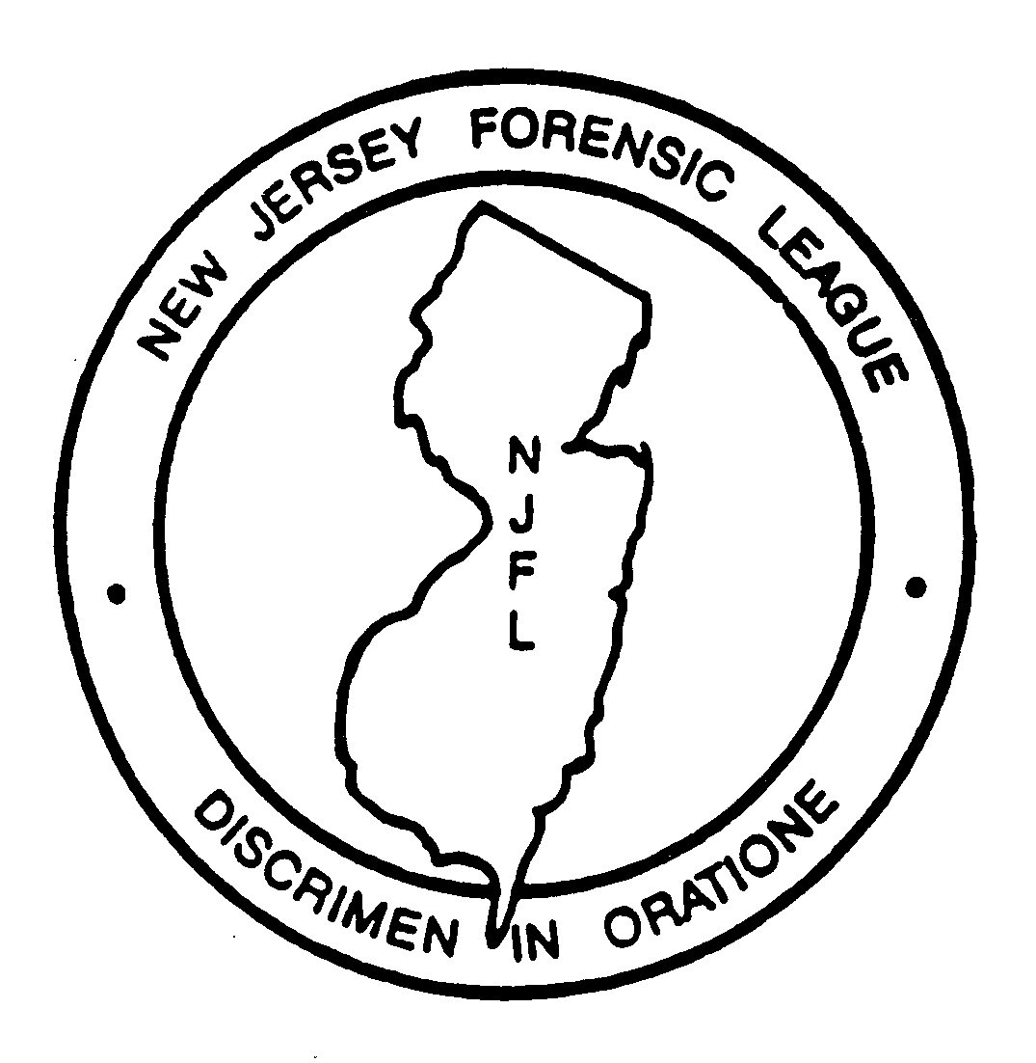

Definition & General Rules: The contestant shall take not less than 5 nor more than 10 minutes to present from memory a talk prepared entirely by him/herself on a topic of his/her own choosing. The contestant is allowed a wide latitude in selecting his/her topic and may choose to inform, persuade, entertain, or achieve a variety of these purposes. The total number of words quoted from other sources must not exceed 150.

Judging Considerations  Content:  - Originality in subject matter.  - Correctness and emphasis of composition, particularly with regard to rules of grammar, word usage, and sentence structure.  Delivery:  - Effective use of vocal qualities such as force, rate, enunciation, and pronunciation.  - Effective use of gesture and facial expression  - General poise  Time Limits:  5 to 10 minutes (with a 30 second grace period).  Please record time here:  ______________ | Comments: Please make comments constructive (including areas of praise and areas needing improvement). Please justify rank accordingly.

Student Code:_________ Judge Signature: __________________________________

Rank (1-8): ________ Rating: ________(A+, A, A-, B+, B, B-)
No ties allowed in rank. Ties are permitted in ratings.

